 

**Personal Learning Portfolio**

**Course： English Academic Writing Teacher： Zhang Mei**

**Class： 002 Major： Computer Science**

**Name： Wen Hongbing Student Number： 20214590**

**Class Time： 2023.02-2023.07**

**Grade：**

|  |  |  |
| --- | --- | --- |
| **Self** | **Teaching Assistant** | **Teacher** |
| **9** |  |  |

**Comments：**

**Teacher (Signature)**

**Contents**

# Week 4

1. **My learning**

(1)Topic Selection

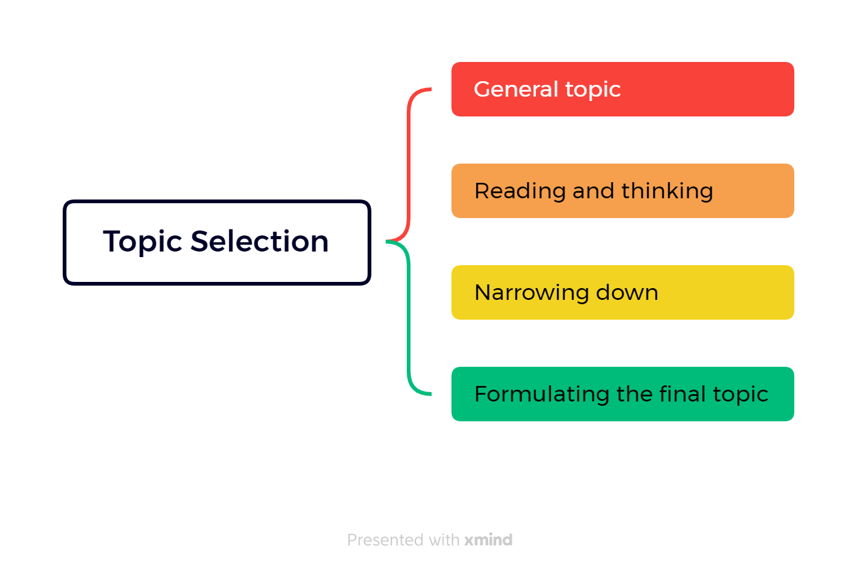

(2)Topic Attention

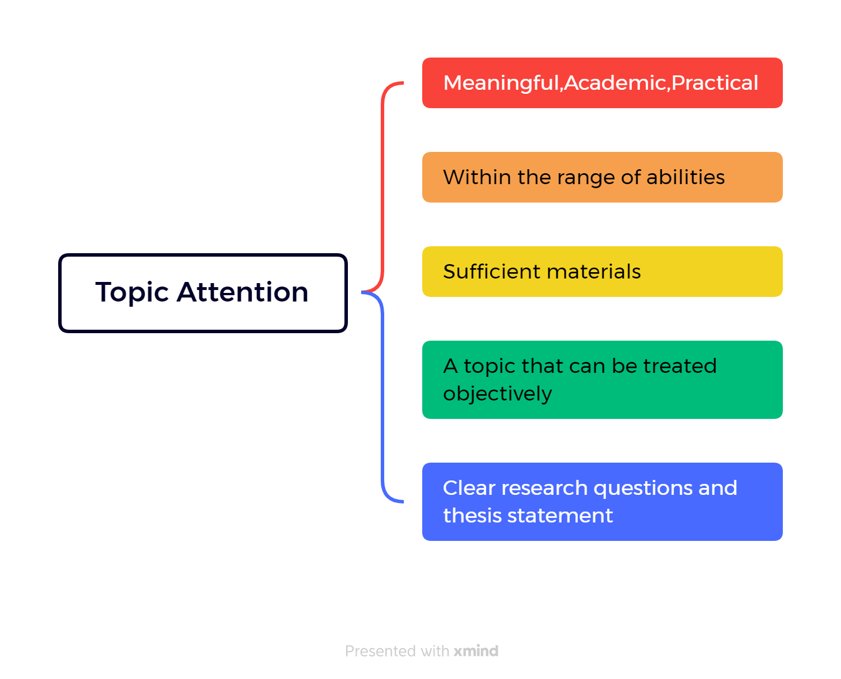

(3)Three keys element of a title

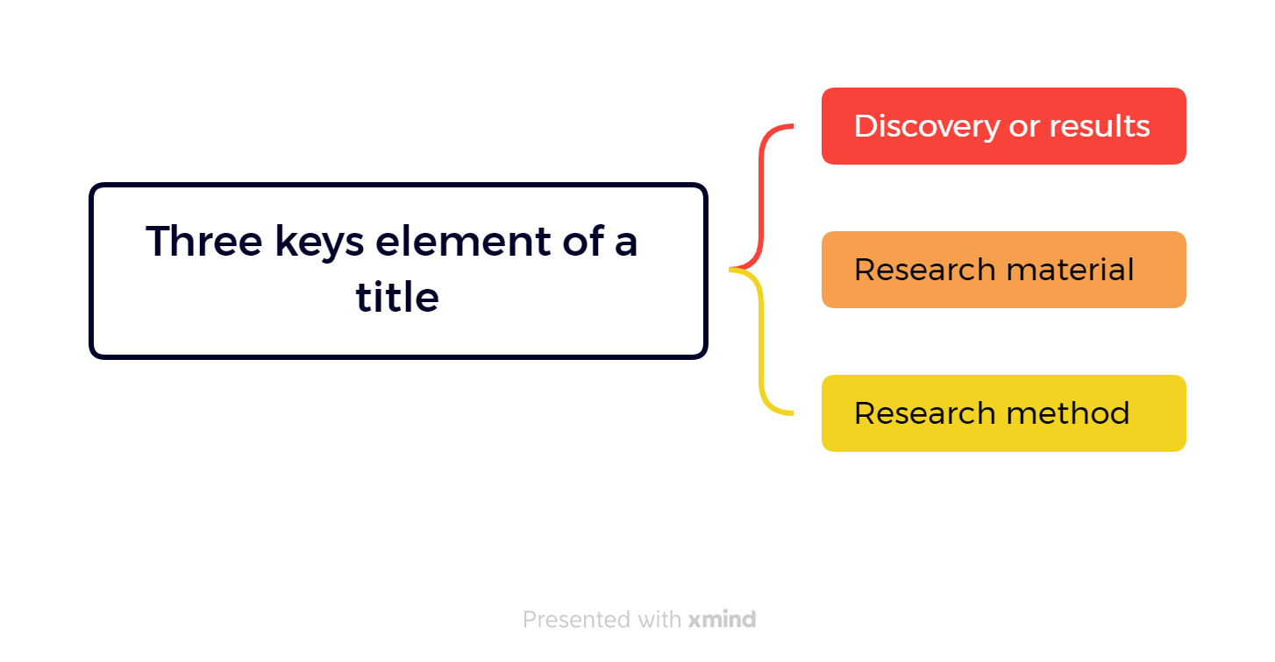

1. **Learning outcomes**

* A good topic should be meaningful, academic, and practical. In the future, I can apply this principle to select research direction and choose topics with research value to better serve the company and society.
* The topic should be researchable and have enough materials available. In the future, I can follow this principle to determine research direction and ensure sufficient data and information support.
* The topic should be treated objectively and have clear research questions and a thesis statement. In the future academic writing, I can follow this principle to ensure that my paper can be understood and accepted by readers.
* Narrowing down the topic is an essential step in the process. In future research, I can use this principle to help me better locate research questions and improve research efficiency.
* Reading and thinking critically about the general topic can help to focus on specific aspects. In future academic research, I can use this principle to help me better understand the research object, and improve research quality.
* A good title should include key elements, such as discovery or results, research material, and research method. In future academic writing, I can use this principle to design more attractive and readable titles to better attract readers to read my papers.
* Selecting a topic for research requires careful consideration and planning. In the future workplace and academic research, I can use this principle to develop better research plans to improve work efficiency and research quality.
* This process helps to develop critical thinking and research skills. In the future, I can use these skills to better evaluate information, solve problems, and improve judgment and decision-making.

1. **My behavior and attitude**

* Questions will be answered, but the quality and depth of the presentation needs to be further improved.
* The cooperation performance is not so good, so we need to participate more actively in class discussions and speeches to enhance our cooperation ability.

1. **Improvement**

* The quality and depth of speech need to be improved: self-access to information, ask more questions.
* Cooperation skills need to be enhanced: active participation in teamwork projects, participation in class discussions and presentations.

# Week 5

1. **My Learning:**
2. Objective and function of the introduction

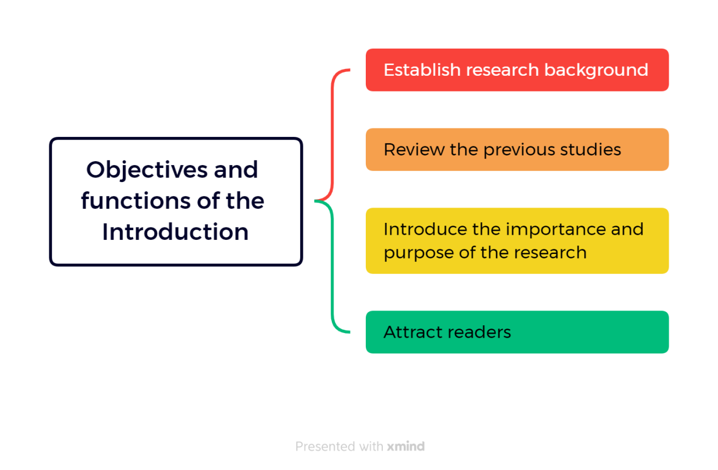

1. How to write a introduction

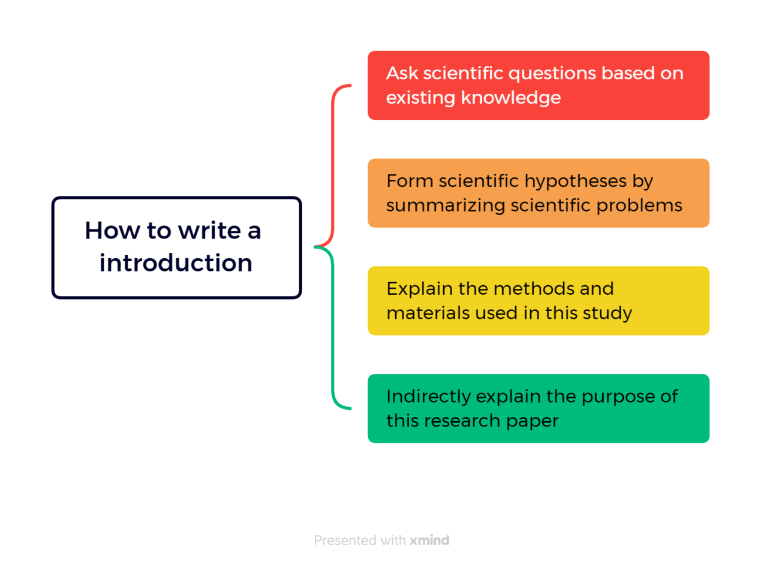

1. Write the introduction in five steps

* General statements about a field of a research to provide the readers with a setting for problems.
* More specific statement about the aspects of the problems already studied by other researchers.
* Statements that indicate the need for more investigation.
* Very specific statement giving the purpose of the writer's study.
* Optional statement that give a value or justification for carrying out the study.

1. Introduction and write a roadmap

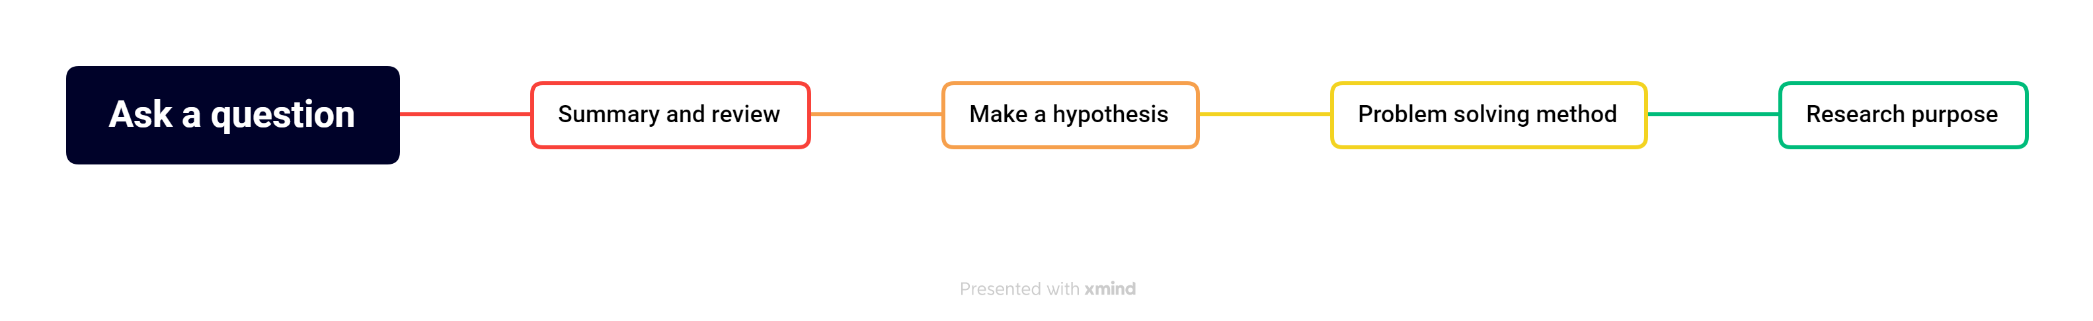

1. English thesis tense

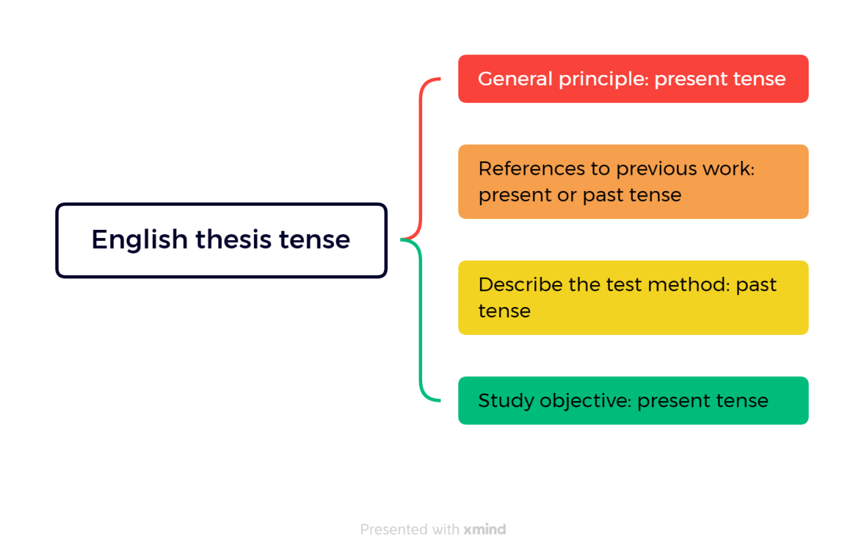

1. Precautions for introduction writing

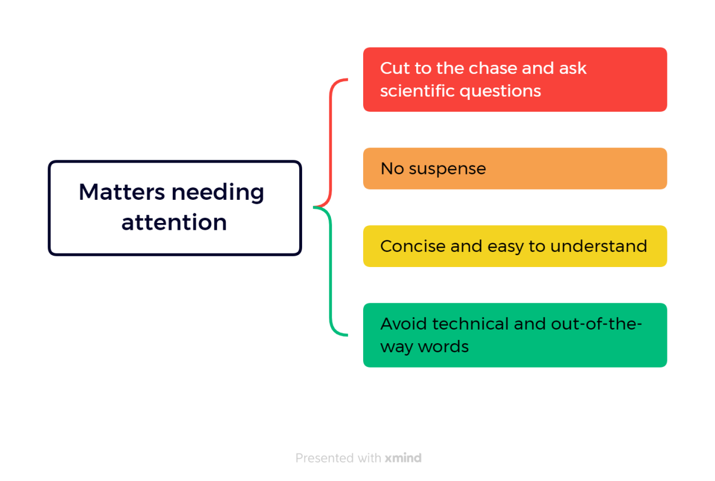

1. **Outcomes:**

* The purpose of the introduction is to provide research background, introduce scientific problems, and enable readers to understand and evaluate the significance of research results.
* Writing the introduction requires moving from general to specific, using the five-step method that includes presenting the problem, reviewing previous research, stating the hypothesis, explaining the methods, and stating the purpose.
* When writing the introduction, it is important to use appropriate tenses, such as the present tense for general principles, the present or past tense for citing previous work, the past tense for describing experimental methods, and the present tense for stating the research purpose.
* The introduction should clearly and concisely present the scientific problem, avoiding leaving readers confused or uncertain.
* Common issues to avoid when writing the introduction include missing important elements, vague descriptions, being overly long and losing focus, having a narrow background, and using overly general statements.
* When writing the introduction, it is important to avoid overly technical or esoteric vocabulary to ensure readers can understand the content.

1. **My behavior and attitude**

* I finish my homework carefully, but sometimes I procrastinate because of improper time management.
* Listen carefully and take notes, but sometimes I miss something important because I lose focus.

1. **Improvement**

* Time mismanagement: Make to-do lists and set time limits.
* Inattention: Reduce distractions and find quiet.

# Week 6

1. **My Learning:**

I read a very illuminating academic paper this week called "The impact of social media on academic writing skills: A review article".

The paper states:

* Heavy use of social networks may have a negative impact on students' English writing ability. Thanks to the popularity of social networks, many people are used to short, colloquial expressions that don't work well in academic writing.
* Over-reliance on social networks for verbal expression may deprive people of the opportunity to practice their academic writing skills.
* However, this paper does not just emphasize the negative effects, but puts forward some effective ways to avoid and overcome these problems. The main recommendations include developing good reading and writing habits, increasing communication with peers and receiving feedback from them, focusing on language norms and using appropriate writing tools to improve writing efficiency.
* All in all, inspired by this article, I realize the importance of maintaining good academic writing habits. In addition to the suggestions made in this paper, I will also pay more attention to reading academic literature and writing exercises. At the same time, I will actively try to use different writing tools and skills to improve my writing efficiency and accuracy.

1. **Outcomes**

* Over-reliance on social networks for verbal expression may deprive people of the opportunity to practice their academic writing skills.
* It is very important to maintain good academic writing habits, including developing good habits of reading and writing, increasing communication with peers and accepting their feedback, paying attention to the standardization of language and using appropriate writing tools to improve writing efficiency.
* In future applications, it is necessary to regularly practice writing, communicate with peers and accept feedback, find suitable writing tools and skills, develop good reading and writing habits, and maintain attention and enthusiasm for the academic field.

1. **My behavior and attitude**

* Pay attention to methods and efficiency,we should pay attention to methods and adopt scientific learning methods and skills to improve learning efficiency.
* Open mind and innovation,in the process of learning, we should have an open mind, accept new ideas and ideas, and have the courage to try and innovate, so as to promote our continuous progress.
* Learning anxiety and learning fatigue, learning anxiety because of the excessive attention to academic performance and results, leading to tension and worry. Learning fatigue is due to the accumulation of negative emotions in the process of learning, resulting in emotional exhaustion.

1. **Improvement**

* Exercise regularly: Proper exercise can relax the brain, relieve tension and anxiety, and improve thinking ability. Schedule some time each day for light aerobic exercise, such as walking and jogging.
* Make a reasonable study plan: Make a systematic study plan, arrange the study time and task allocation, avoid excessive study burden or time pressure and other situations